**PERSIAPAN SURVEY**

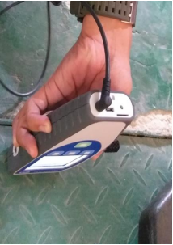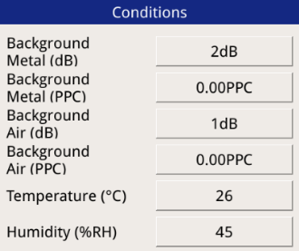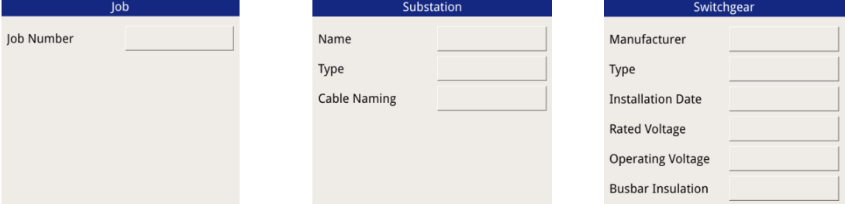

Isi terserah (misal 1)



**Mer/Kun/Bir**

Nama GI

Indoor/Outdoor



Jangan lupa pasang sensor

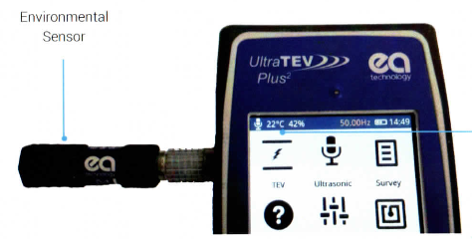

Merk Kubikel

Jenis isolasi BB

Tahun Operasi

Teg Rating

Teg Operasi

Tempel ke bahan metal disekitar yang tidak terhubung dengan peralatan yang diukur (pintu, APAR, dll.)

Type Kubikel



Tanda jika survey sudah diset dan sedang berjalan

(Biru → Hijau)

**RECORD DAN LOKASI PENYIMPANAN RECORD**

Kabel Power (TEV, RFCT)

Jalur Kabel (Flex Mic) 🡪 pilih fasa manapun utk record beri komentar “jalur kabel”

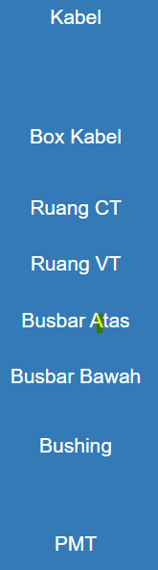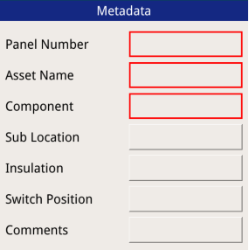

No. Trafo

Lain2 ->Ketik “TRF (no TRF)”

Box Bushing LV (Contact Probe, Flex Mic)

Kabel/Box Kabel/dst

Sesuai lokasi sensor

Kubikel Incoming

(TEV, Contact Probe, Flex Mic)

XLPE/Minyak/dll

Pilih salah satu tergantung desain kubikel

Tutup/Buka

*Keterangan

Terminasi LV Outdoor (Ultradish)

Lubang Kabel Box Bushing LV (Ultradish)

Kubikel Incoming (TEV, Contact Probe, Flex Mic)

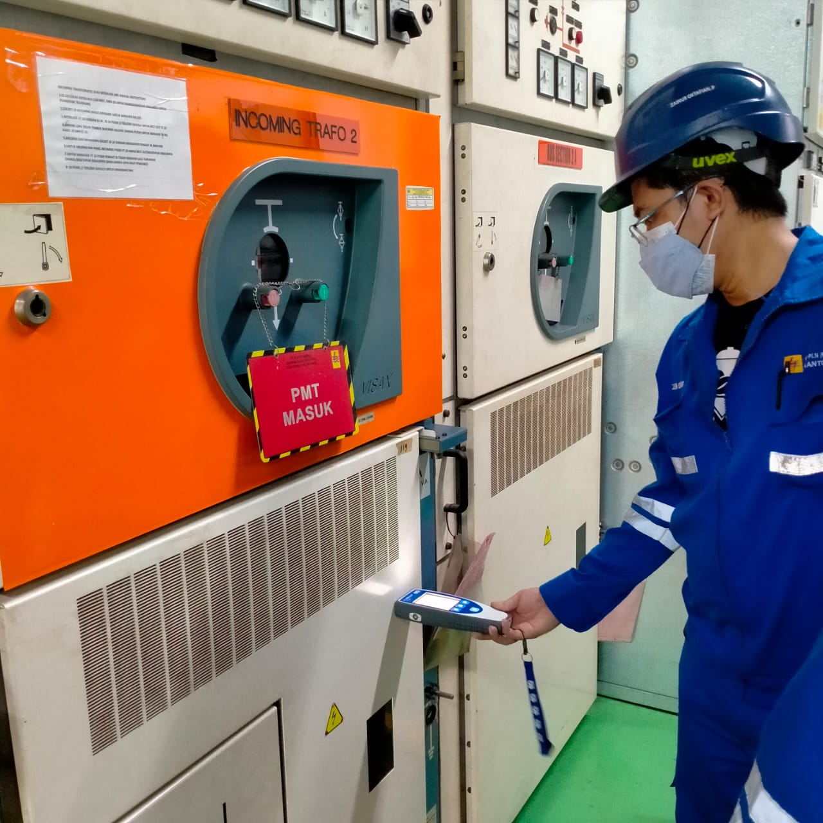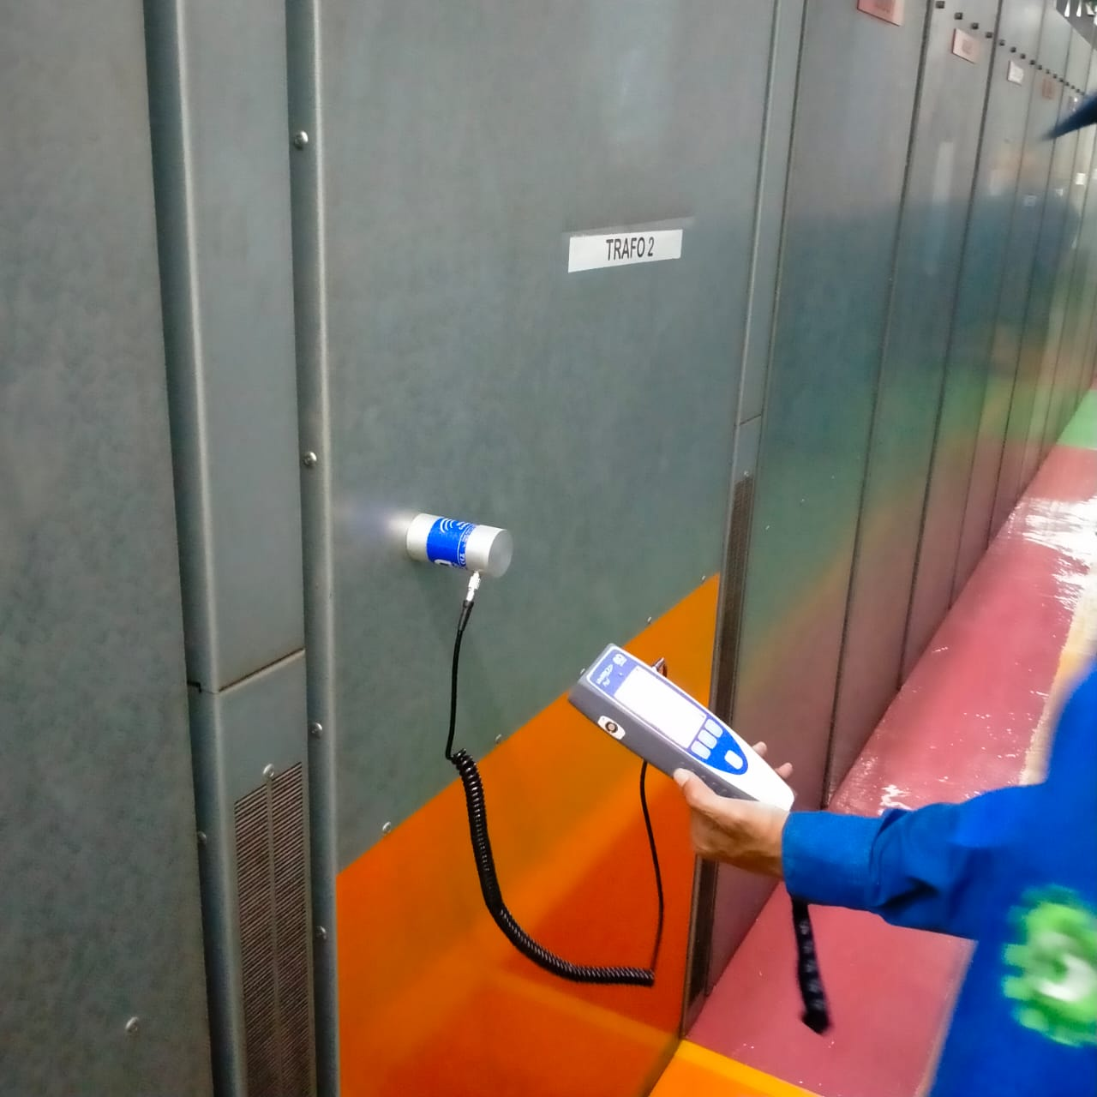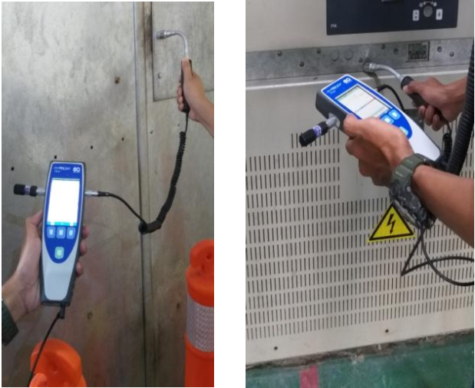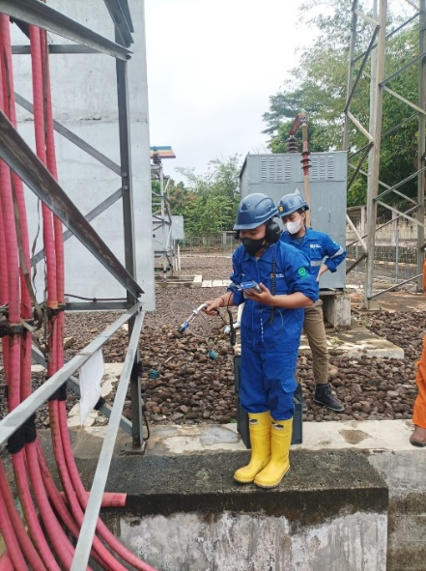 **TITIK PENGUJIAN**

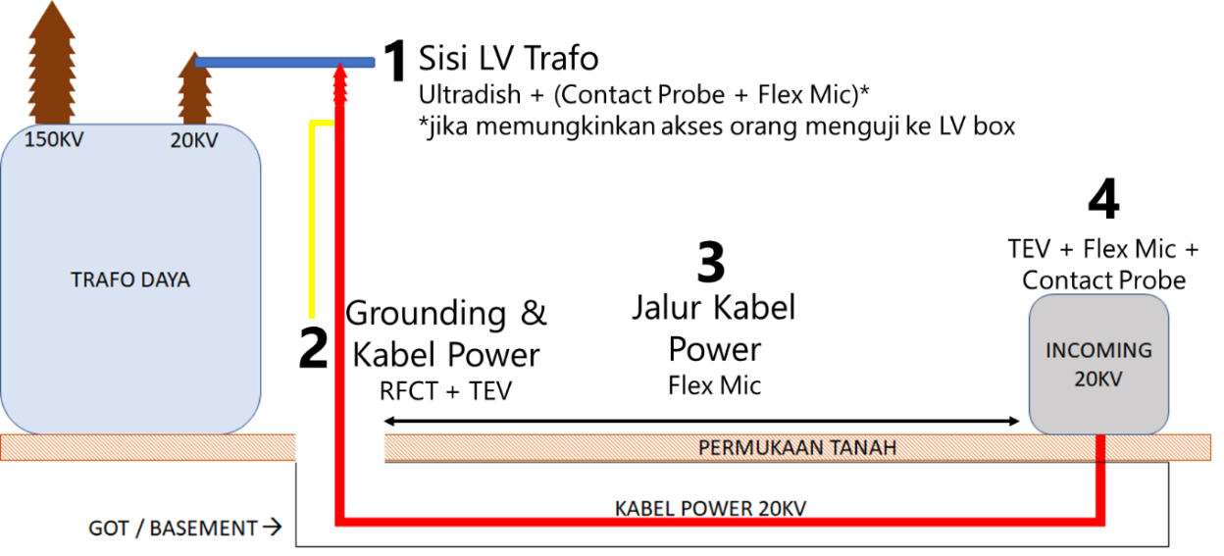

1. **ULTRADISH PADA LV TRAFO**

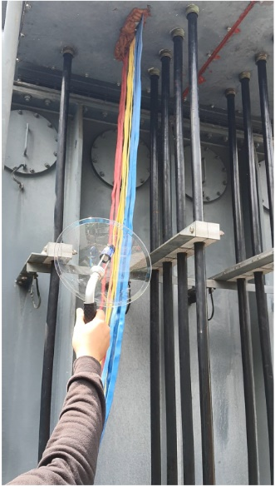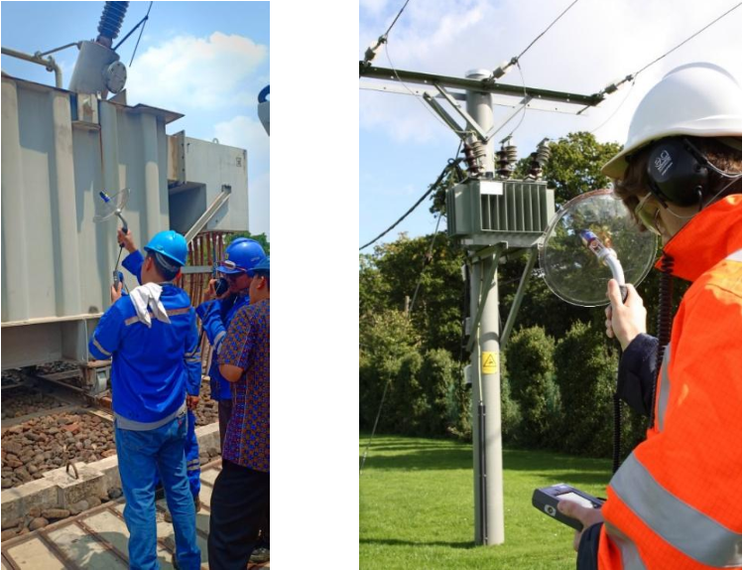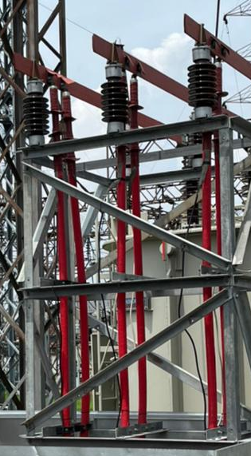

1. **FLEX MIC & CONTACT PROBE PADA BOX LV TRAFO**

**\***DILAKUKAN HANYA JIKA MEMUNGKINKAN

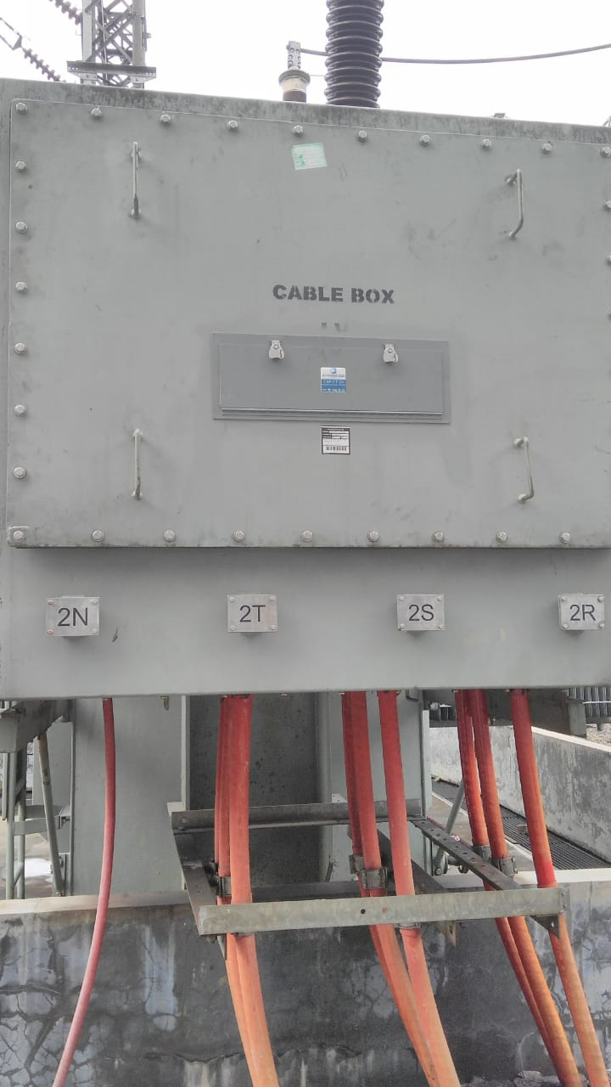 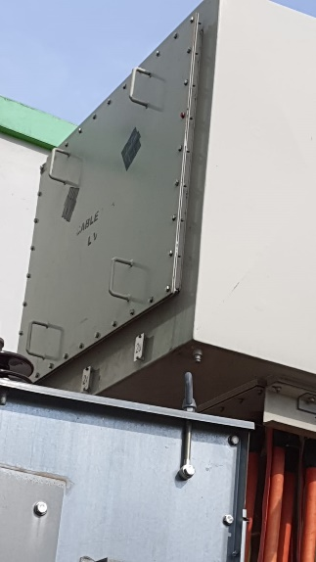

Contact probe

Flex mic

Flex mic

Flex mic

Flex mic

1. **TEV PADA KABEL POWER**

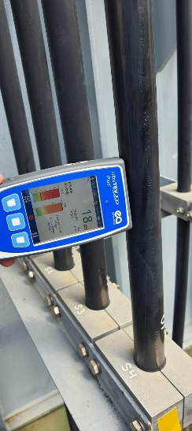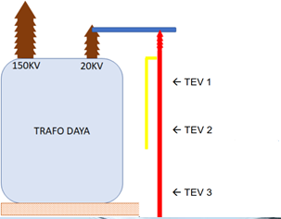

ambil nilai tertinggi saja

1. **HFCT PADA GROUNDING KABEL POWER**

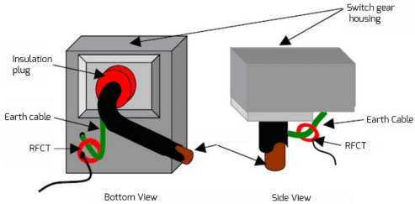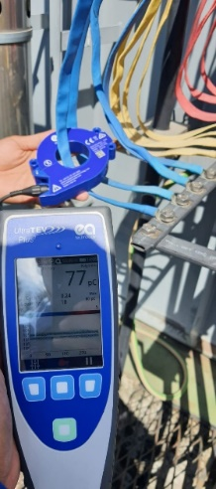

1. **FLEX MIC PADA JALUR KABEL POWER**

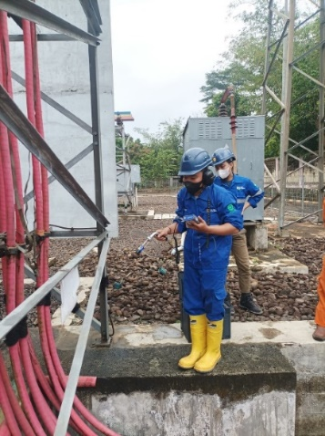

1. **TEV, CONTACT PROBE, FLEX MIC PADA KUBIKEL INCOMING**

  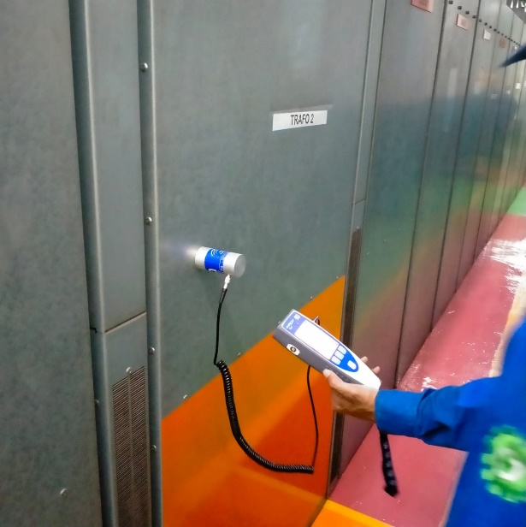

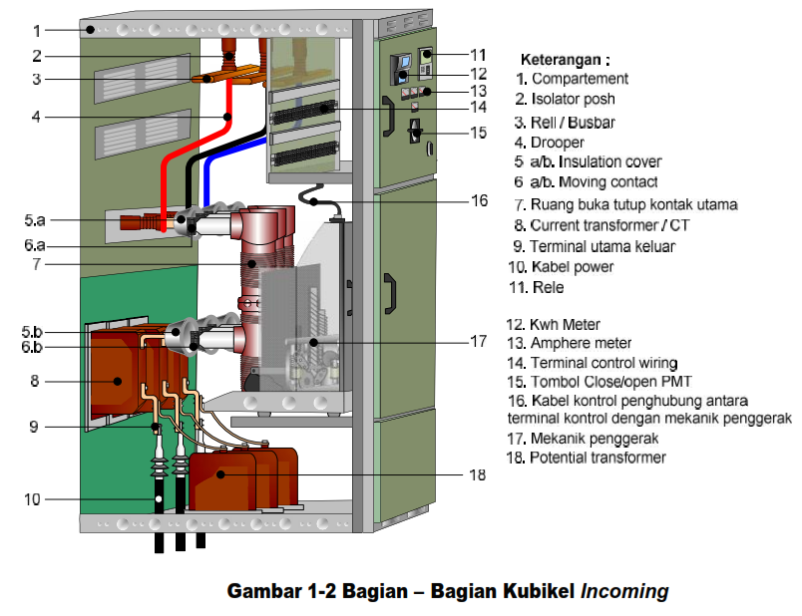

**PENGAMBILAN DATA ULTRASONIK**

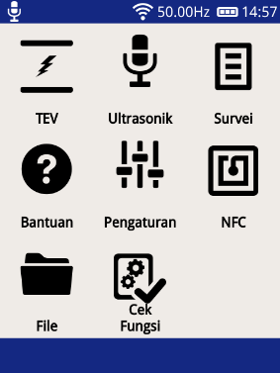 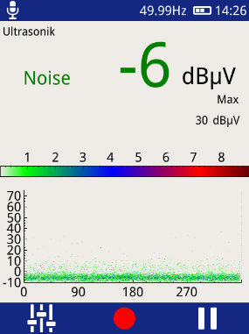 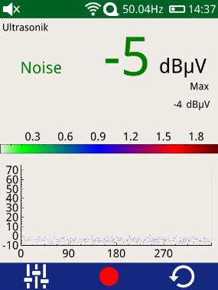 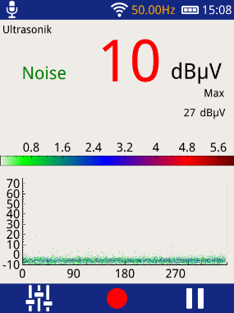

PRPD



1.Pilih menu “ultrasonik” 2.Reset PRPD dengan 3.Klik simbol “back” 4. Catat jika ada dua

Klik simbol “pause” kluster puncak di PRPD.

Klik “record”.

 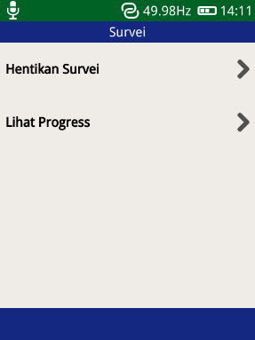 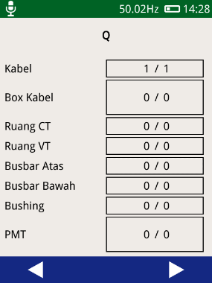 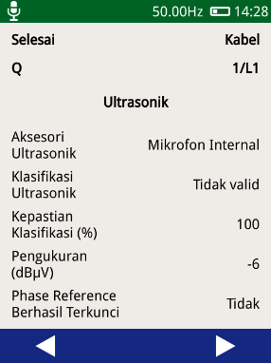

Klasifikasi

Kepastian

Magnitude

5.Pilih menu “Survei” 6.Pilih “Lihat Progres” 8.Pilih lokasi 9.Catat parameter

**PENGAMBILAN DATA HFCT**

Click Hand Cursor Png, Transparent Png , Transparent Png Image - PNGitem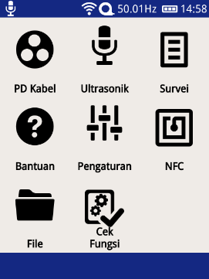 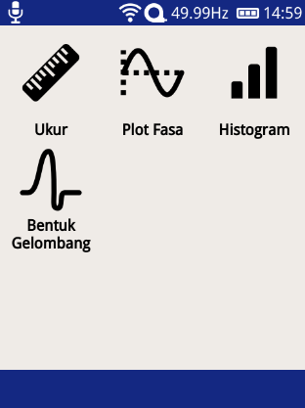 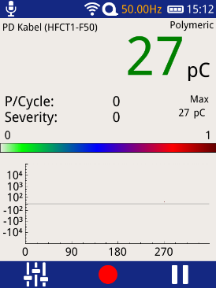

Magnitude

Pulse Per Cycle

PRPD

1.Pilih menu “PD Kabel” 2.Pilih Menu “Plot Fasa” 3.Klik tombol “Pause” 2x

Untuk reset PRPD.

Catat parameter.

 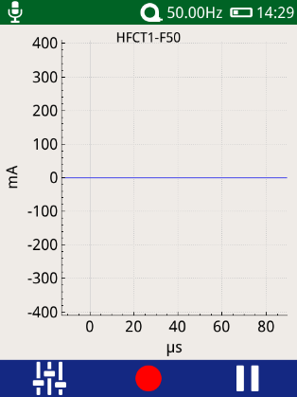

waveform

4.Tekan tombol back, pilih menu 5. Amati jika ada bentuk

“bentuk gelombang” unipolar waveform. Catat.

**PENGAMBILAN DATA TEV**

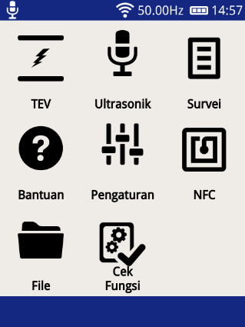 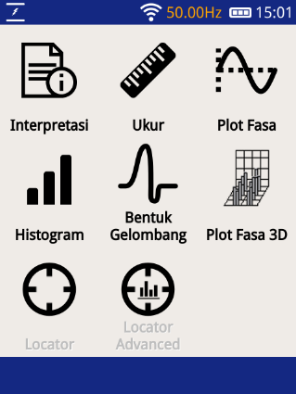 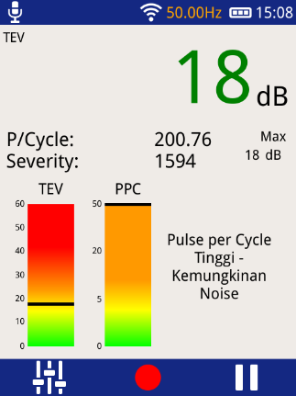

interpretasi

Pulse per cycle

magnitude

1.Pilih Menu “TEV” 2.Pilih menu “Interpretasi” 3.Catat parameter

**DIAGNOSA PD ULRASONIK, HFCT, TEV**

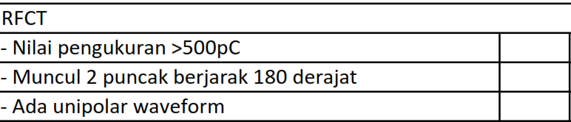

Ultrasonik

√

√

√

AND

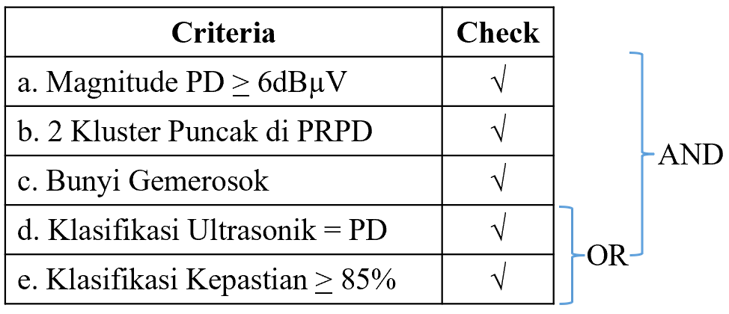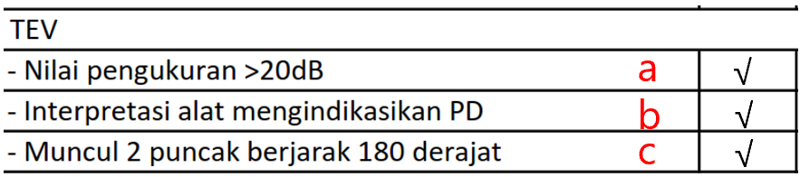

AND

**CEK HASIL (VIA HANDPHONE) 🡪 192.168.11.1**

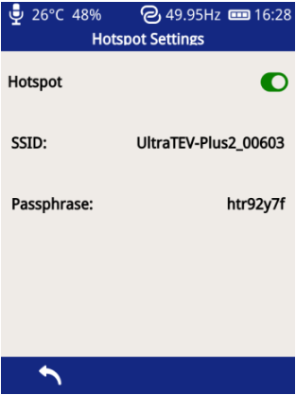Pastikan survey sudah berhenti / tersimpan (bar atas berwarna biru)

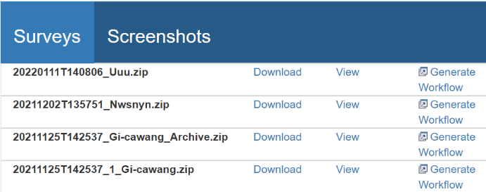

Klik view untuk menampilkan / klik download untuk menyimpan ZIP ke HP. Gunakan untuk interpretasi

*SSID & Passphrase bisa berbeda tergantung alat

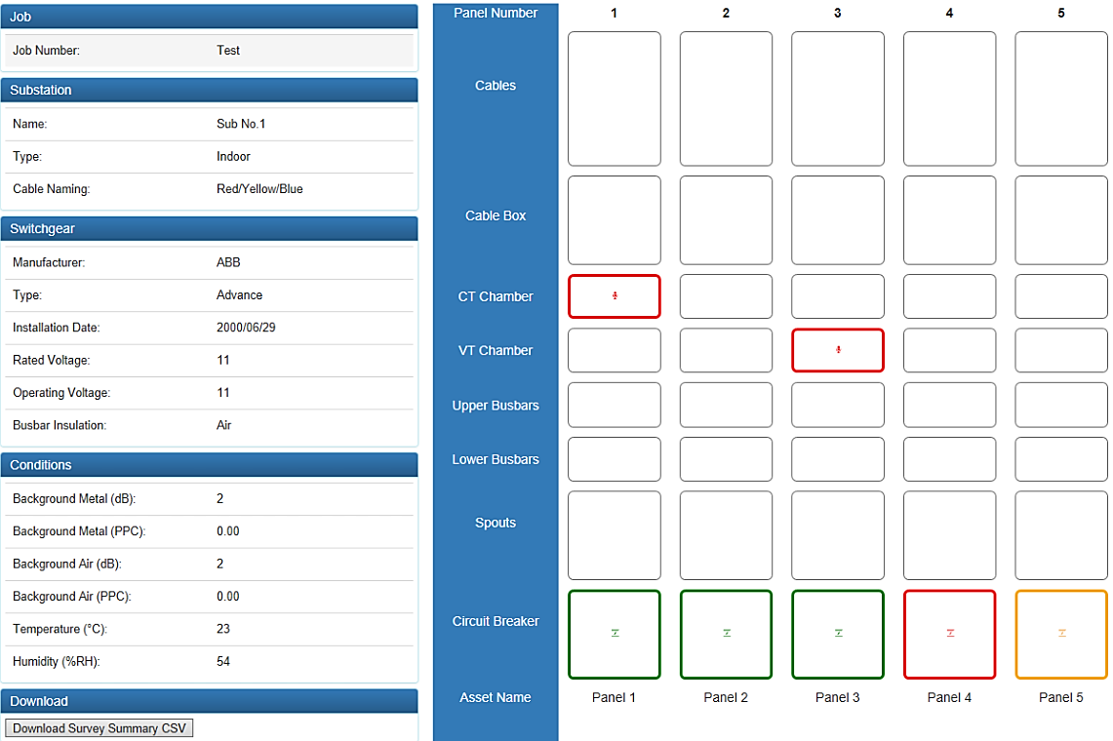

Klik masing2 ikon untuk menampilkan hasil record

**LAPORAN PENGUJIAN PARTIAL DISCHARGE KABEL POWER DAN KUBIKEL INCOMING 20KV**

**(ONLINE)**

GARDU INDUK : {{ halaman_depan.gardu_induk }}

TANGGAL : {{ halaman_depan.hari }}/{{ halaman_depan.bulan }}/{{ halaman_depan.tahun }}

JAM : {{ halaman_depan.jam }}:{{ halaman_depan.menit }}



PT. PLN (PERSERO)

UNIT INDUK TRANSMISI JAWA BAGIAN BARAT

UPT CILEGON

ULTG RANGKASBITUNG

|  |  |  |  |  |  |  |  |  |  |  |  |  |  |  |  |  |  |
| --- | --- | --- | --- | --- | --- | --- | --- | --- | --- | --- | --- | --- | --- | --- | --- | --- | --- |
| **INFORMASI UMUM** | | | | | | | | | | | | | | | | | |
| Suhu | | | | | : | {{ formulir_laporan.data_umum.suhu }} oC | | | | {% set L = formulir_laporan.indikasi_pd.beban_trafo_list or [] %}  {% if L|length > 0 %}  Beban {{ L[0].name }}  {% endif %} | | | | : | {% if L|length > 0 %}  {{ L[0].value }} A  {% endif %} |
| Kelembaban | | | | | : | {{ formulir_laporan.data_umum.kelembaban }} % | | | | {% if L|length > 1 %}  Beban {{ L[1].name }}  {% endif %} | | | | : | {% if L|length > 1 %}  {{ L[1].value }} A  {% endif %} |
|  | | |  |  | | | | | | {% if L|length > 2 %}  Beban {{ L[2].name }}  {% endif %} | | | | : | {% if L|length > 2 %}  {{ L[2].value }} A  {% endif %} |
|  | | |  |  | | | | | | {% if L|length > 3 %}  Beban {{ L[3].name }}  {% endif %} | | | | : | {% if L|length > 3 %}  {{ L[3].value }} A  {% endif %} |
|  | | |  |  | | | | | | {% if L|length > 4 %}  Beban {{ L[4].name }}  {% endif %} | | | | : | {% if L|length > 4 %}  {{ L[4].value }} A  {% endif %} |
| **SUMMARY** | | | | | | | | | | | | | | | | |
| **Titik Pengujian** | | | | | | | **Gunakan Tabel Interpretasi Hasil**  **Ada Indikasi PD? (**✔ **/** ✖ **)** | | | | | | **Lokasi Temuan** | | | |
| **TRF#1** | **TRF#2** | **TRF#3** | | **TRF#4** | **TRF# 5** |
| 1. LV Trafo | | | | | | |  |  |  | |  |  |  | | | |
|  | a. | Ultradish | | | | | {% for row in formulir_laporan.indikasi_pd.rows %}  {% if row.titik == "Sisi LV Trafo" and row.sensor == "Ultradish" %}  {{ "✓" if row.trafo|length > 0 and row.trafo[0]["yes"] else ("X" if row.trafo|length > 0 else "") }} | {{ "✓" if row.trafo|length > 1 and row.trafo[1]["yes"] else ("X" if row.trafo|length > 1 else "") }} | {{ "✓" if row.trafo|length > 2 and row.trafo[2]["yes"] else ("X" if row.trafo|length > 2 else "") }} | | {{ "✓" if row.trafo|length > 3 and row.trafo[3]["yes"] else ("X" if row.trafo|length > 3 else "") }} | {{ "✓" if row.trafo|length > 4 and row.trafo[4]["yes"] else ("X" if row.trafo|length > 4 else "") }} | {% set lokasi_list = row.trafo | selectattr("yes", "equalto", true) | map(attribute="lokasi") | list %}  {{ lokasi_list | join(", ") if lokasi_list else "" }} {% endif %}  {% endfor %} | | | |
|  | b. | Contact Probe* | | | | | {% for row in formulir_laporan.indikasi_pd.rows %}  {% if row.titik == "Sisi LV Trafo" and row.sensor == "Contact Probe*" %}  {{ "✓" if row.trafo|length > 0 and row.trafo[0]["yes"] else ("X" if row.trafo|length > 0 else "") }} | {{ "✓" if row.trafo|length > 1 and row.trafo[1]["yes"] else ("X" if row.trafo|length > 1 else "") }} | {{ "✓" if row.trafo|length > 2 and row.trafo[2]["yes"] else ("X" if row.trafo|length > 2 else "") }} | | {{ "✓" if row.trafo|length > 3 and row.trafo[3]["yes"] else ("X" if row.trafo|length > 3 else "") }} | {{ "✓" if row.trafo|length > 4 and row.trafo[4]["yes"] else ("X" if row.trafo|length > 4 else "") }} | {% set lokasi_list = row.trafo | selectattr("yes", "equalto", true) | map(attribute="lokasi") | list %}  {{ lokasi_list | join(", ") if lokasi_list else "" }} {% endif %}  {% endfor %} | | | |
|  | c. | Flexible Mic* | | | | | {% for row in formulir_laporan.indikasi_pd.rows %}  {% if row.titik == "Sisi LV Trafo" and row.sensor == "Flexible Mic*" %}  {{ "✓" if row.trafo|length > 0 and row.trafo[0]["yes"] else ("X" if row.trafo|length > 0 else "") }} | {{ "✓" if row.trafo|length > 1 and row.trafo[1]["yes"] else ("X" if row.trafo|length > 1 else "") }} | {{ "✓" if row.trafo|length > 2 and row.trafo[2]["yes"] else ("X" if row.trafo|length > 2 else "") }} | | {{ "✓" if row.trafo|length > 3 and row.trafo[3]["yes"] else ("X" if row.trafo|length > 3 else "") }} | {{ "✓" if row.trafo|length > 4 and row.trafo[4]["yes"] else ("X" if row.trafo|length > 4 else "") }} | {% set lokasi_list = row.trafo | selectattr("yes", "equalto", true) | map(attribute="lokasi") | list %}  {{ lokasi_list | join(", ") if lokasi_list else "" }} {% endif %}  {% endfor %} | | | |
| 1. Kabel Power 20kV | | | | | | |  |  |  | |  |  |  | | | |
|  | a. | HFCT | | | | | {% for row in formulir_laporan.indikasi_pd.rows %}  {% if row.titik == "Kabel Power 20kV" and row.sensor == "HFCT" %}  {{ "✓" if row.trafo|length > 0 and row.trafo[0]["yes"] else ("X" if row.trafo|length > 0 else "") }} | {{ "✓" if row.trafo|length > 1 and row.trafo[1]["yes"] else ("X" if row.trafo|length > 1 else "") }} | {{ "✓" if row.trafo|length > 2 and row.trafo[2]["yes"] else ("X" if row.trafo|length > 2 else "") }} | | {{ "✓" if row.trafo|length > 3 and row.trafo[3]["yes"] else ("X" if row.trafo|length > 3 else "") }} | {{ "✓" if row.trafo|length > 4 and row.trafo[4]["yes"] else ("X" if row.trafo|length > 4 else "") }} | {% set lokasi_list = row.trafo | selectattr("yes", "equalto", true) | map(attribute="lokasi") | list %}  {{ lokasi_list | join(", ") if lokasi_list else "" }} {% endif %}  {% endfor %} | | | |
|  | b. | TEV | | | | | {% for row in formulir_laporan.indikasi_pd.rows %}  {% if row.titik == "Kabel Power 20kV" and row.sensor == "TEV" %}  {{ "✓" if row.trafo|length > 0 and row.trafo[0]["yes"] else ("X" if row.trafo|length > 0 else "") }} | {{ "✓" if row.trafo|length > 1 and row.trafo[1]["yes"] else ("X" if row.trafo|length > 1 else "") }} | {{ "✓" if row.trafo|length > 2 and row.trafo[2]["yes"] else ("X" if row.trafo|length > 2 else "") }} | | {{ "✓" if row.trafo|length > 3 and row.trafo[3]["yes"] else ("X" if row.trafo|length > 3 else "") }} | {{ "✓" if row.trafo|length > 4 and row.trafo[4]["yes"] else ("X" if row.trafo|length > 4 else "") }} | {% set lokasi_list = row.trafo | selectattr("yes", "equalto", true) | map(attribute="lokasi") | list %}  {{ lokasi_list | join(", ") if lokasi_list else "" }} {% endif %}  {% endfor %} | | | |
| 1. Jalur Kabel | | | | | | |  |  |  | |  |  |  | | | |
|  | a. | Flexible Mic | | | | | {% for row in formulir_laporan.indikasi_pd.rows %}  {% if row.titik == "Jalur Kabel 20kV" and row.sensor == "Flexible Mic" %}  {{ "✓" if row.trafo|length > 0 and row.trafo[0]["yes"] else ("X" if row.trafo|length > 0 else "") }} | {{ "✓" if row.trafo|length > 1 and row.trafo[1]["yes"] else ("X" if row.trafo|length > 1 else "") }} | {{ "✓" if row.trafo|length > 2 and row.trafo[2]["yes"] else ("X" if row.trafo|length > 2 else "") }} | | {{ "✓" if row.trafo|length > 3 and row.trafo[3]["yes"] else ("X" if row.trafo|length > 3 else "") }} | {{ "✓" if row.trafo|length > 4 and row.trafo[4]["yes"] else ("X" if row.trafo|length > 4 else "") }} | {% set lokasi_list = row.trafo | selectattr("yes", "equalto", true) | map(attribute="lokasi") | list %}  {{ lokasi_list | join(", ") if lokasi_list else "" }} {% endif %}  {% endfor %} | | | |
| 1. Kubikel Incoming | | | | | | |  |  |  | |  |  |  | | | |
|  | a. | TEV | | | | | {% for row in formulir_laporan.indikasi_pd.rows %}  {% if row.titik == "Kubikel Incoming 20kV" and row.sensor == "TEV” %}  {{ "✓" if row.trafo|length > 0 and row.trafo[0]["yes"] else ("X" if row.trafo|length > 0 else "") }} | {{ "✓" if row.trafo|length > 1 and row.trafo[1]["yes"] else ("X" if row.trafo|length > 1 else "") }} | {{ "✓" if row.trafo|length > 2 and row.trafo[2]["yes"] else ("X" if row.trafo|length > 2 else "") }} | | {{ "✓" if row.trafo|length > 3 and row.trafo[3]["yes"] else ("X" if row.trafo|length > 3 else "") }} | {{ "✓" if row.trafo|length > 4 and row.trafo[4]["yes"] else ("X" if row.trafo|length > 4 else "") }} | {% set lokasi_list = row.trafo | selectattr("yes", "equalto", true) | map(attribute="lokasi") | list %}  {{ lokasi_list | join(", ") if lokasi_list else "" }} {% endif %}  {% endfor %} | | | |
|  | b. | Flexible Mic | | | | | {% for row in formulir_laporan.indikasi_pd.rows %}  {% if row.titik == "Kubikel Incoming 20kV" and row.sensor == "Flexible Mic" %}  {{ "✓" if row.trafo|length > 0 and row.trafo[0]["yes"] else ("X" if row.trafo|length > 0 else "") }} | {{ "✓" if row.trafo|length > 1 and row.trafo[1]["yes"] else ("X" if row.trafo|length > 1 else "") }} | {{ "✓" if row.trafo|length > 2 and row.trafo[2]["yes"] else ("X" if row.trafo|length > 2 else "") }} | | {{ "✓" if row.trafo|length > 3 and row.trafo[3]["yes"] else ("X" if row.trafo|length > 3 else "") }} | {{ "✓" if row.trafo|length > 4 and row.trafo[4]["yes"] else ("X" if row.trafo|length > 4 else "") }} | {% set lokasi_list = row.trafo | selectattr("yes", "equalto", true) | map(attribute="lokasi") | list %}  {{ lokasi_list | join(", ") if lokasi_list else "" }} {% endif %}  {% endfor %} | | | |
|  | c. | Contact Probe | | | | | {% for row in formulir_laporan.indikasi_pd.rows %}  {% if row.titik == "Kubikel Incoming 20kV" and row.sensor == "Contact Probe" %}  {{ "✓" if row.trafo|length > 0 and row.trafo[0]["yes"] else ("X" if row.trafo|length > 0 else "") }} | {{ "✓" if row.trafo|length > 1 and row.trafo[1]["yes"] else ("X" if row.trafo|length > 1 else "") }} | {{ "✓" if row.trafo|length > 2 and row.trafo[2]["yes"] else ("X" if row.trafo|length > 2 else "") }} | | {{ "✓" if row.trafo|length > 3 and row.trafo[3]["yes"] else ("X" if row.trafo|length > 3 else "") }} | {{ "✓" if row.trafo|length > 4 and row.trafo[4]["yes"] else ("X" if row.trafo|length > 4 else "") }} | {% set lokasi_list = row.trafo | selectattr("yes", "equalto", true) | map(attribute="lokasi") | list %}  {{ lokasi_list | join(", ") if lokasi_list else "" }} {% endif %}  {% endfor %} | | | |

*dilakukan hanya jika akses ke box bushing LV trafo memungkinkan (tidak wajib)

Diperiksa Oleh, Dilaksanakan Oleh,

TL HAR GI ULTG ………………….

(…………………………………….) (……………………………………)

Disetujui Oleh,

MULTG ………………….

(…………………………………….)

**{% for trafo_id, trafo in formulir_laporan.kubikel_incoming.items() %}**

**LEMBAR PENGUJIAN PARTIAL DISCHARGE**

**KUBIKEL INCOMING 20KV**

**Data Kubikel Incoming**

|  |  |  |  |  |  |
| --- | --- | --- | --- | --- | --- |
| Merk | : | {{ trafo.extra_fields.Merk }} | Trafo No. | : | {{ trafo_id }} |
| Type | : | {{ trafo.extra_fields.Type }} | Frekuensi Lock (Putih/Kuning) | : | {{ trafo.frekuensi_lock }} |
| Tahun Buat | : | {{ trafo.extra_fields['Tahun Buat'] }} |  |  |
| Tahun Operasi | : | {{ trafo.extra_fields['Tahun Operasi'] }} |  |  |

**Standar Nilai Pengujian**

|  |  |  |  |
| --- | --- | --- | --- |
| TEV |  | Ultrasonic (Flex Mic / Contact Probe) | |
| Normal | < 20 dB | Normal | < 6 dBµV |
| Perlu Perhatian | 20 – 29 dB **RECORD!** | Berbahaya | > 6 dBµV + PD **CATAT +RECORD!** |
| Berbahaya | > 29 dB **RECORD!** |  |  |

*Interpretasi TEV

* 1. Tidak memerlukan perhatian
  2. PPC tinggi, kemungkianan noise
  3. Kemungkinan PD tingkat rendah
  4. Kemungkinan Discharge Permukaan – Cek Ultrasonik

Jika interpretasi c - g muncul, **RECORD !**

* 1. Kemungkinan PD tingkat menengah
  2. Kemungkinan PD tingkat tinggi
  3. Kemungkinan logam mengambang / koneksi jelek

|  |  |  |  |
| --- | --- | --- | --- |
| **Titik** | **TEV** | | |
| **Nilai (dB)** | **PPC** | **Interpretasi\***  **(a - g)** |
| {% for row in trafo.tables.tev %}  {{ row.titik }} | {{ row.nilai }} | {{ row.ppc }} | {{ row.interpretasi }} |
| {% endfor %} |  |  |  |

|  |  |  |  |  |  |
| --- | --- | --- | --- | --- | --- |
| **Titik** | **Contact Probe** | | | | |
| **Nilai (dBµV)** | **Kepastian (%)** | **Interpretasi (PD/Noise)** | **Suara Gemerosok**  **(Ada/Tidak)** | **Cluster Dua Gelombang**  **(Ada/Tidak)** |
| {% for row in trafo.tables.contact_probe %}  {{ row.titik }} | {{ row.nilai }} | {{ row.kepastian }} | {{ row.interpretasi }} | {{ row.suara_gemerosok }} | {{ row.cluster_dua_gelombang }} |
| {% endfor %} |  |  |  |  |  |

|  |  |  |  |  |  |  |
| --- | --- | --- | --- | --- | --- | --- |
| **Titik** | **Flexible Mic** | | | | | |
| **Nilai (dBµV)** | **Kepastian (%)** | **Interpretasi (PD/Noise)** | **Suara Gemerosok**  **(Ada/Tidak)** | **Cluster Dua Gelombang**  **(Ada/Tidak)** | **Lokasi Temuan** |
| {% for row in trafo.tables.flexible_mic %} {{ row.titik }} | {{ row.nilai }} | {{ row.kepastian }} | {{ row.interpretasi }} | {{ row.suara_gemerosok }} | {{ row.cluster_dua_gelombang }} | {{ row.lokasi_temuan }} |
| {% endfor %} |  |  |  |  |  |  |

{% endfor %}

*dokumentasikan lokasi titik penemuan indikasi PD

*Cetak sesuai jumlah trafo*

**{% for trafo_id, trafo in formulir_laporan.jalur_kabel.items() %}**

**LEMBAR PENGUJIAN PARTIAL DISCHARGE**

**JALUR KABEL 20KV**

**Standar Nilai Pengujian**

|  |  |  |  |  |
| --- | --- | --- | --- | --- |
| Frekuensi Lock (Putih/Kuning) | : | {{ trafo.frekuensi_lock }} | Normal | < 6 dBµV |
|  |  | Berbahaya | > 6 dBµV + PD **CATAT+RECORD!** |

|  |  |  |  |  |  |  |
| --- | --- | --- | --- | --- | --- | --- |
| **Titik** | **Flexible Mic** | | | | | |
| **Nilai (dBµV)** | **Kepastian (%)** | **Interpretasi (PD/Noise)** | **Suara Gemerosok**  **(Ada/Tidak)** | **Cluster Dua Gelombang**  **(Ada/Tidak)** | **Lokasi Temuan** |
| {% for row in trafo.table.flexible_mic %} {{ row.titik }} | {{ row.nilai }} | {{ row.kepastian }} | {{ row.interpretasi }} | {{ row.suara_gemerosok }} | {{ row.cluster_dua_gelombang }} | {{ row.lokasi_temuan }} |
| {% endfor %} |  |  |  |  |  |  |

{% endfor %}

*dokumentasikan lokasi titik penemuan indikasi PD

**{% for trafo_id, trafo in formulir_laporan.kabel_power.items() %}**

**LEMBAR PENGUJIAN PARTIAL DISCHARGE**

**KABEL POWER 20KV**

**Data Kabel Power 20kV *Setting Khusus Mode HFCT**

|  |  |  |  |  |  |
| --- | --- | --- | --- | --- | --- |
| Trafo No. | : | {{ trafo_id }} | Set ke “PD Kabel” | : | {{ trafo.settings["Set Mode ke 'Kabel PD'"] }} |
| Merk Kabel | : | {{ trafo.data_kabel["Merk Kabel"] }} | Set ke “500kHz High Pass” | : | {{ trafo.settings["Set Filter ke '500kHz High Pass'"] }} |
| Ukuran | : | {{ trafo.data_kabel["Ukuran"] }} mm2 | Frekuensi Lock  (Putih/Kuning) | : | {{ trafo.settings["Frekuensi Lock"] }} |
| Tahun Operasi | : | {{ trafo.data_kabel["Tahun Operasi"] }} |  |  |

**Standar Nilai**

|  |  |  |  |
| --- | --- | --- | --- |
| TEV |  | HFCT |  |
| Normal | 0 – 20 dB | Normal | < 250 pC |
| Perlu Perhatian | 21 – 29 dB **RECORD!** | Perlu Perhatian | 250 – 500 pC **RECORD!** |
| Berbahaya | >29 dB **RECORD!** | Berbahaya | >500 pC **RECORD!** |

*Interpretasi TEV

1. Tidak memerlukan perhatian
2. PPC tinggi, kemungkianan noise
3. Kemungkinan PD tingkat rendah
4. Kemungkinan Discharge Permukaan – Cek Ultrasonik

Jika interpretasi c - g muncul, **RECORD !**

1. Kemungkinan PD tingkat menengah
2. Kemungkinan PD tingkat tinggi
3. Kemungkinan logam mengambang / koneksi jelek

|  |  |  |  |  |  |  |  |  |
| --- | --- | --- | --- | --- | --- | --- | --- | --- |
| **FASA** | **CORE** | **TEV** | | | **HFCT** | | | |
| **Nilai**  **(dB)** | **PPC** | **Interpretasi\***  **(a - g)** | **Nilai (pC)** | **PPC** | **Unipolar Waveform**  **(Ada/Tidak)** | **Cluster Dua Gelombang**  **(Ada/Tidak)** |
| R | 1 | {{ trafo.tables.tev[0].nilai | default("") }} | {{ trafo.tables.tev[0].ppc | default("") }} | {{ trafo.tables.tev[0].interpretasi | default("") }} | {{ trafo.tables.hfct[0].nilai | default("") }} | {{ trafo.tables.hfct[0].ppc | default("") }} | {{ trafo.tables.hfct[0].unipolar_waveform | default("") }} | {{ trafo.tables.hfct[0].cluster_dua_gelombang | default("") }} |
| 2 | {{ trafo.tables.tev[1].nilai | default("") }} | {{ trafo.tables.tev[1].ppc | default("") }} | {{ trafo.tables.tev[1].interpretasi | default("") }} | {{ trafo.tables.hfct[1].nilai | default("") }} | {{ trafo.tables.hfct[1].ppc | default("") }} | {{ trafo.tables.hfct[1].unipolar_waveform | default("") }} | {{ trafo.tables.hfct[1].cluster_dua_gelombang | default("") }} |
| 3 | {{ trafo.tables.tev[2].nilai | default("") }} | {{ trafo.tables.tev[2].ppc | default("") }} | {{ trafo.tables.tev[2].interpretasi | default("") }} | {{ trafo.tables.hfct[2].nilai | default("") }} | {{ trafo.tables.hfct[2].ppc | default("") }} | {{ trafo.tables.hfct[2].unipolar_waveform | default("") }} | {{ trafo.tables.hfct[2].cluster_dua_gelombang | default("") }} |
| 4 | {{ trafo.tables.tev[3].nilai | default("") }} | {{ trafo.tables.tev[3].ppc | default("") }} | {{ trafo.tables.tev[3].interpretasi | default("") }} | {{ trafo.tables.hfct[3].nilai | default("") }} | {{ trafo.tables.hfct[3].ppc | default("") }} | {{ trafo.tables.hfct[3].unipolar_waveform | default("") }} | {{ trafo.tables.hfct[3].cluster_dua_gelombang | default("") }} |
| S | 1 | {{ trafo.tables.tev[4].nilai | default("") }} | {{ trafo.tables.tev[4].ppc | default("") }} | {{ trafo.tables.tev[4].interpretasi | default("") }} | {{ trafo.tables.hfct[4].nilai | default("") }} | {{ trafo.tables.hfct[4].ppc | default("") }} | {{ trafo.tables.hfct[4].unipolar_waveform | default("") }} | {{ trafo.tables.hfct[4].cluster_dua_gelombang | default("") }} |
| 2 | {{ trafo.tables.tev[5].nilai | default("") }} | {{ trafo.tables.tev[5].ppc | default("") }} | {{ trafo.tables.tev[5].interpretasi | default("") }} | {{ trafo.tables.hfct[5].nilai | default("") }} | {{ trafo.tables.hfct[5].ppc | default("") }} | {{ trafo.tables.hfct[5].unipolar_waveform | default("") }} | {{ trafo.tables.hfct[5].cluster_dua_gelombang | default("") }} |
| 3 | {{ trafo.tables.tev[6].nilai | default("") }} | {{ trafo.tables.tev[6].ppc | default("") }} | {{ trafo.tables.tev[6].interpretasi | default("") }} | {{ trafo.tables.hfct[6].nilai | default("") }} | {{ trafo.tables.hfct[6].ppc | default("") }} | {{ trafo.tables.hfct[6].unipolar_waveform | default("") }} | {{ trafo.tables.hfct[6].cluster_dua_gelombang | default("") }} |
| 4 | {{ trafo.tables.tev[7].nilai | default("") }} | {{ trafo.tables.tev[7].ppc | default("") }} | {{ trafo.tables.tev[7].interpretasi | default("") }} | {{ trafo.tables.hfct[7].nilai | default("") }} | {{ trafo.tables.hfct[7].ppc | default("") }} | {{ trafo.tables.hfct[7].unipolar_waveform | default("") }} | {{ trafo.tables.hfct[7].cluster_dua_gelombang | default("") }} |
| T | 1 | {{ trafo.tables.tev[8].nilai | default("") }} | {{ trafo.tables.tev[8].ppc | default("") }} | {{ trafo.tables.tev[8].interpretasi | default("") }} | {{ trafo.tables.hfct[8].nilai | default("") }} | {{ trafo.tables.hfct[8].ppc | default("") }} | {{ trafo.tables.hfct[8].unipolar_waveform | default("") }} | {{ trafo.tables.hfct[8].cluster_dua_gelombang | default("") }} |
| 2 | {{ trafo.tables.tev[9].nilai | default("") }} | {{ trafo.tables.tev[9].ppc | default("") }} | {{ trafo.tables.tev[9].interpretasi | default("") }} | {{ trafo.tables.hfct[9].nilai | default("") }} | {{ trafo.tables.hfct[9].ppc | default("") }} | {{ trafo.tables.hfct[9].unipolar_waveform | default("") }} | {{ trafo.tables.hfct[9].cluster_dua_gelombang | default("") }} |
| 3 | {{ trafo.tables.tev[10].nilai | default("") }} | {{ trafo.tables.tev[10].ppc | default("") }} | {{ trafo.tables.tev[10].interpretasi | default("") }} | {{ trafo.tables.hfct[10].nilai | default("") }} | {{ trafo.tables.hfct[10].ppc | default("") }} | {{ trafo.tables.hfct[10].unipolar_waveform | default("") }} | {{ trafo.tables.hfct[10].cluster_dua_gelombang | default("") }} |
| 4 | {{ trafo.tables.tev[11].nilai | default("") }} | {{ trafo.tables.tev[11].ppc | default("") }} | {{ trafo.tables.tev[11].interpretasi | default("") }} | {{ trafo.tables.hfct[11].nilai | default("") }} | {{ trafo.tables.hfct[11].ppc | default("") }} | {{ trafo.tables.hfct[11].unipolar_waveform | default("") }} | {{ trafo.tables.hfct[11].cluster_dua_gelombang | default("") }} |

{% if not loop.last %}<w:br w:type="page"/>{% endif %}

{% endfor %}

*Cetak sesuai jumlah trafo*

**{% for trafo_id, trafo in formulir_laporan.sisi_lv_trafo.items() %}**

**LEMBAR PENGUJIAN PARTIAL DISCHARGE**

**SISI LV TRAFO**

**Standar Nilai Pengujian**

|  |  |  |  |  |
| --- | --- | --- | --- | --- |
| Frekuensi Lock (Putih/Kuning) | : | {{ trafo.frekuensi_lock }} | Normal | < 6 dBµV |
|  |  | Berbahaya | > 6 dBµV + PD **CATAT +** **RECORD!** |

Isian Lokasi Muncul PD*

|  |  |  |  |  |
| --- | --- | --- | --- | --- |
| Fasa R Core 1 |  | Fasa S Core 1 |  | Fasa T Core 1 |
| Fasa R Core 2 |  | Fasa S Core 2 |  | Fasa T Core 2 |
| Fasa R Core 3 |  | Fasa S Core 3 |  | Fasa T Core 3 |
| Fasa R Core 4 |  | Fasa S Core 4 |  | Fasa T Core 4 |

Terminasi LV (terbuka)

|  |  |  |  |  |  |  |
| --- | --- | --- | --- | --- | --- | --- |
| **Lokasi** | **Ultradish** | | | | | |
| **Nilai (dBµV)** | **Kepastian (%)** | **Interpretasi (PD/Noise)** | **Suara Gemerosok** | **Cluster Dua Gelombang** | **Lokasi Muncul PD\*** |
| {% for row in trafo.tables.ultradish %} {{ row.titik }} | {{ row.nilai }} | {{ row.kepastian }} | {{ row.interpretasi }} | {{ row.suara_gemerosok }} | {{ row.cluster_dua_gelombang }} | Fasa {{ row.lokasi_fasa }} Core {{ row.lokasi_core }} |
| {% endfor %} |  |  |  |  |  |  |

Box Bushing LV (tertutup)

|  |  |  |  |  |  |  |
| --- | --- | --- | --- | --- | --- | --- |
| **Lokasi** | **Flexible Mic** | | | | | |
| **Nilai (dBµV)** | **Kepastian (%)** | **Interpretasi (PD/Noise)** | **Suara Gemerosok** | **Cluster Dua Gelombang** | **Lokasi Muncul PD\*** |
| {% for row in trafo.tables.flexible_mic %} {{ row.titik }} | {{ row.nilai }} | {{ row.kepastian }} | {{ row.interpretasi }} | {{ row.suara_gemerosok }} | {{ row.cluster_dua_gelombang }} | Fasa {{ row.lokasi_fasa }} Core {{ row.lokasi_core }} |
| {% endfor %} |  |  |  |  |  |  |

|  |  |  |  |  |  |  |
| --- | --- | --- | --- | --- | --- | --- |
| **Lokasi** | **Contact Probe** | | | | | |
| **Nilai (dBµV)** | **Kepastian (%)** | **Interpretasi (PD/Noise)** | **Suara Gemerosok** | **Cluster Dua Gelombang** | **Lokasi Muncul PD\*** |
| {% for row in trafo.tables.contact_probe %} {{ row.titik }} | {{ row.nilai }} | {{ row.kepastian }} | {{ row.interpretasi }} | {{ row.suara_gemerosok }} | {{ row.cluster_dua_gelombang }} | Fasa {{ row.lokasi_fasa }} Core {{ row.lokasi_core }} |
| {% endfor %} |  |  |  |  |  |  |

{% endfor %}

*Cetak sesuai jumlah trafo*